1. Write short answers to the following questions:
a. What is meant by "database"?
b. Why do organizations store data?
c. Define "data" in one line.
d. Define "information" in one line.
e. What does a DBMS do?
f. Write any two examples of DBMS.
g. State one goal of a DBMS regarding duplication.
h. What does the INT data type represent?
i. What is the primary use of VARCHAR?
j. What does the DATE data type store?
k. What is a table in a database?
l. What is a record (tuple)?
m. What is a field (column)?
n. What is a primary key?
o. What is a foreign key?
p. What is referential integrity?
q. What does the CREATE command do?
r. What does the ALTER command do?
s. What does the DROP command do?
t. What does the SELECT command do?
u. Write about AND Operator.
v. Why use OR operator?

2. Write the long answer to the following questions:
a. Explain briefly how databases aid decision-making.
b. How does a DBMS speed up searching?
c. Why are backups important in databases?
d. Differentiate between data and information with a simple example.
e. Why is choosing the correct data type necessary?
f. When would you prefer DECIMAL over FLOAT?
g. When is CHAR more suitable than VARCHAR?
h. What kind of content suits VARCHAR(MAX)?
i. Why should every table have a primary key?
j. Why do we relate tables using foreign keys?
k. How does a DBMS allow safe multi-user access?
l. What risk comes with dropping a table?
m. Why might we alter a table after deployment?
n. Give one practical reason to update existing data.
o. What precaution is needed before deleting rows?
p. Why are queries referred to as "questions to the database"?
q. How do reports relate to queries in real use?
r. Why reduce duplicate data in databases?
s. Why should changes be instantly visible to users?
t. Why does the accuracy of stored data matter?
u. Write the importance of BETWEEN operator.

1. Write short answers to the following questions

a. What is meant by "database"?
A database is an organized collection of related data stored electronically for easy access and management.

b. Why do organizations store data?
Organizations store data to keep records, make decisions, and manage their operations efficiently.

c. Define "data" in one line.
Data is a collection of raw facts and figures.

d. Define "information" in one line.
Information is processed and organized data that is meaningful.

e. What does a DBMS do?
A DBMS (Database Management System) stores, organizes, retrieves, updates, and manages data efficiently.

f. Write any two examples of DBMS.
The two examples of DBMS are:
- MySQL
- Oracle Database

g. State one goal of a DBMS regarding duplication.
A DBMS goal is to reduce data duplication (redundancy).

h. What does the INT data type represent?
The INT data type stores whole numbers (integers).

i. What is the primary use of VARCHAR?
VARCHAR is used to store variable-length text or characters.

j. What does the DATE data type store?
The DATE data type stores dates in the format YYYY-MM-DD.

k. What is a table in a database?
A table is a collection of related data arranged in rows and columns.

l. What is a record (tuple)?
A record (tuple) is a single row in a table containing information about one item.

m. What is a field (column)?
A field (column) is a single attribute or category of data in a table.

n. What is a primary key?
A primary key is a field that uniquely identifies each record in a table.

o. What is a foreign key?
A foreign key is a field that links one table to another by referring to the primary key of another table.

p. What is referential integrity?
Referential integrity ensures that relationships between tables remain valid and consistent.

q. What does the CREATE command do?
The CREATE command is used to create database objects such as databases and tables.

r. What does the ALTER command do?
The ALTER command is used to modify the structure of an existing table.

s. What does the DROP command do?
The DROP command permanently deletes a database object such as a table or database.

t. What does the SELECT command do?
The SELECT command retrieves data from one or more tables.

u. Write about AND Operator.
The AND operator returns records only when all specified conditions are true.

v. Why use OR operator?
The OR operator returns records when at least one of the specified conditions is true.

2. In a long answer, respond to the following questions:
a. Describe in short a role of a database in decision making.
Databases contain huge quantities of accurate and meaningful data which assist users to easily locate the information they need, create reports, and analyze data and helps organizations to make informed and timely decisions.

b. What happens to the speed of searching if a DBMS is used?
A DBMS is a program that organizes the data and provides the ability to query the data which enables us to locate specific information much quicker than manually searching.

c. Why is it important to make backups in databases?
The backup is useful because it safeguards the data from getting lost because of hardware failure, software mistakes, viruses or accidental deletion. In case data is lost, it can be recovered from the back up.

d. Differentiate between data and information with a simple example.
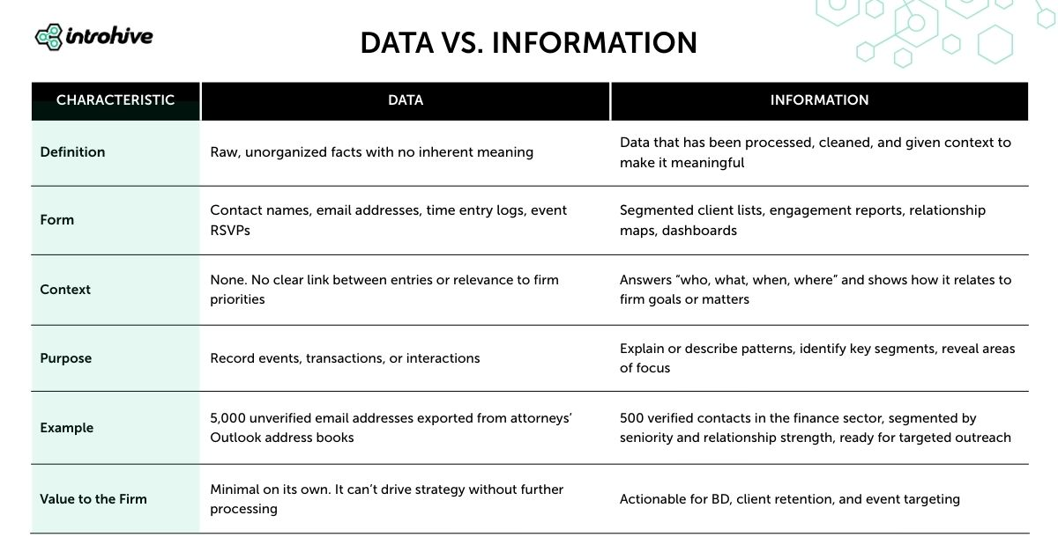

e. Why is it important to select the right type of data?
Selecting the right data type aids accurately storing data, save storage space, increase its performance, and lower errors during data entry.

f. When would you prefer DECIMAL over FLOAT?
When precise values are needed, as in financial or banking calculations, DECIMAL is preferred to FLOAT, since it is more precise.

g. When to use CHAR vs VARCHAR?
CHAR is better for use when the data does not vary in length, like a gender code (M/F) or a country code, due to the fixed length storage.

h. Which type of data is suitable for VARCHAR(MAX)?
VARCHAR(MAX) is for storing a very large text, e.g. descriptions, comments, articles, notes, etc. which may be larger than the usual text size.

i. Why is it that all tables must have a primary key?
Each table should have a primary key since it will uniquely identify each record in the table. It eliminates duplicate records and simplifies data searching and updating.

j. Why use foreign keys to relate tables?
Relationships are made between tables with foreign keys. They ensure consistency of data and ensure that related data is accurate.

k. How can a DBMS ensure multiple users can access the system safely?
Several users can access the database simultaneously and can control access, and prevent conflicts, using a DBMS. This ensures the data is safe and reliable.

l. What is the danger of dropping a table?
When a table is dropped, all the data in the table will be deleted as well as the table itself. After deletion, the information can only be retrieved if a backup exists.

m. What could be reasons for changing a table after deployment?
A table can be modified even after deployment by adding new columns and removing columns that are not required or changing the data type of existing columns to meet changing requirements.

n. Provide one real-world justification for updating of any data.
Current data is updated to maintain accurate and up-to-date records. For instance, if there are changes in the customer's address or phone number, this may need to be updated.

o. Which is the right precaution to take before removing rows?
When deleting rows, it is important to check that the data that has been selected is the correct data and also make sure to take a back up copy of the data to prevent unintentional loss.

p. Why is it that a query is also called a "question to the database"?
Queries are referred to as "questions to the database" because they ask for specific information from the database, which then returns the relevant information.

q. In practice, how do reports relate to queries?
User queries fetch the information from the database and reports display that information in a user-friendly manner.

r. So why store redundant data in databases?
Eliminating duplicate data frees up storage space, enhances data quality and simplifies database administration.

s. Why does it make sense to users to have to wait to see changes?
Changes should be immediately visible to ensure that everyone is using the most up to date and accurate information, eliminating confusion and wrongdoing.

t. Why is it important that the data in storage is accurate?
Because Data is essential for creating reports, making decisions and avoiding errors.

u. Write the importance of BETWEEN operator.
To get values within a range, use the BETWEEN operator. It simplifies queries, makes them more easily understood, and lessens multiple conditions.
These answers are suitable for examination questions that require 5–10 marks: they are well presented, clear and informative, but not too wordy.

